Miniature Masterworks Artist Application
Connecting Collectors & Artists

APPLICATIONS ARE DUE BY MAY 31, 2023
APPLICATIONS CAN BE
- DOWNLOADED FROM TOYANDMINIATUREMUSEUM.ORG/PROGRAMS-EVENTS/ AND EMAILED TO: TOYMINIMUSEUM@GMAIL.COM
- MAILED TO THE NATIONAL MUSEUM OF TOYS AND MINIATURES, ATTN: MINIATURE MASTERWORKS, 5235 OAK STREET, KANSAS CITY, MO 64112, UNITED STATES

Miniature Masterworks is a juried show hosted by The National Museum of Toys and Miniatures (T/m) held at the University of Missouri – Kansas City in Kansas City, Missouri, USA, September 13-15, 2024. All artists working in the field of miniatures are eligible to apply. Approximately 65 of the best miniature artists will be chosen for this honor. Participants will be selected by a committee of experts in the field. The selection process will be based on quality of past work, including type of work, collector interest, rarity, price range, and fit. Once selected, participants will be required to sign a contract and pay a show fee. All artists selected for inclusion in the show will be eligible to compete for the Barbara Marshall Award for Artistic Achievement (1st place award = $15,000, 2nd place award = $10,000, 3rd place award = $5,000) and will receive a contest application with their notice of acceptance.

Applicants will be notified on the status of acceptance to the juried competition by September 1, 2023.

ARTIST DETAILS

Name: ________________________________________________________________________________________
Street Address: _________________________________________________________________________________
City: ____________________________________________ State: _____________ Zip Code: ________________
Country: _________________________ Home Phone: __________________ Cell Phone: _________________
Business Name: ________________________________________________________________________________
Website: _________________________________________ Email: _______________________________________

PLEASE DESCRIBE YOUR WORK

Do you work in a specific period or style?

How long have you been making miniatures?

Have you ever worked under a different name or business name? If so, please list the name(s).

How long have you been selling your work?

Approximately how many pieces are you considering bringing to the show?

What is the price range of your work?

What other shows are you applying to in 2024?

Are there any special pieces you would like to tell us about?

Do you attract clients that don’t attend the usual miniature shows? What would make them consider attending this miniature show?

ROOM AND TABLE ARRANGEMENT
Miniature Masterworks will be held inside Pierson Auditorium in the Atterbury Student Success Center on the University of Missouri – Kansas City (UMKC) campus. Additional events will take place at The National Museum of Toys and Miniatures, also located on the UMKC campus. The campus is fully ADA accessible. Below is a brief description of the space.

PIERSON AUDITORIUM (see Appendix for layout)
Located on the second floor of the Student Success Center, this ballroom will be set up with 6-foot rectangular tables around the perimeter and interior space.

Miniature Masterworks will try to accommodate artist preferences for table sharing, proximity to other artists, and display options. Each table costs $300—black tablecloths and skirts will be provided along with 2 chairs. A limited amount of space will be available for storing cases and other supplies that cannot fit under artists’ tables and will not be needed during the show. T/m will do its best to accommodate all requests.

Dining options for artists and patrons will be available at the UMKC Café, located on the first floor of the Student Success Center. This dining area features Starbucks Coffee and grab-and-go food items.

T/m will provide drinks and snacks for artists in a room near Pierson Auditorium.

Miniature Masterworks desires to include as many artists as possible in a limited amount of space. Therefore, table sharing is encouraged. Both artists must be juried into the showcase, and both will be eligible to submit an entry for the Barbara Marshall Award for Artistic Achievement.

The registration cost of a 6’ rectangular table with two chairs is $300. A limited number of suites with additional space is $450.
regular table ($300)
suite ($450)

Do you want to share a table? (Artists will split the cost of the table.)
Yes. With whom? ____________________________________________________________________________
No

Will packing material, additional stock, and other materials fit under your table for the duration of the show?
Yes
No, I will need extra space. If so, how much (in square feet or meters, please specify)? ______________________

How much time do you anticipate you will need for setup? ________________________________________________

The following materials must be submitted to be considered for Miniature Masterworks. All images and text you provide as part of your application may be used by The National Museum of Toys and Miniatures in the show’s marketing materials and publications. The following material can be sent directly to masterworks@toyandminiaturemuseum.org or shared via Google Drive:

HEADSHOT
Submit one headshot photographed on a white or solid background. The headshot is preferred as a TIF file and must be at least 280 dpi. Image can be sent via Google Drive, flash drive, or email.

PHOTOS OF RECENT WORK
Submit 3-4 images of recent artwork that represent the diversity of your work. If you work in more than one medium, please be sure that the images reflect that. High-resolution TIF images are preferred and must be at least 280dpi. Images can be sent via Google Drive, flash drive, or email.

SHORT BIOGRAPHY
The 500-1,000 word biography should address your artistic background, including educational information, formal exhibitions, breadth of work, and other pertinent details. Please include year of birth and any other names you have worked under.

ARTIST STATEMENT
Please provide a statement (150-200 words) describing the meaning behind your work, and your artistic process. The statement should include details about your materials, process, technique, philosophy, and inspiration.

SEND HEADSHOTS, PHOTOS, BIOGRAPHY, AND ARTIST STATEMENT TO
Email/Google Drive: toyminimuseum@gmail.com

MAIL APPLICATIONS TO
Miniature Masterworks Administrator
5235 Oak Street
Kansas City, MO 64112
United States

OR EMAIL APPLICATIONS TO
toyminimuseum@gmail.com

QUESTIONS?
Contact the T/m Team at 816-235-8004 or toyminimuseum@gmail.com.

If you experience any hardship or technical difficulty in the process of the application, please do not hesitate to reach out for assistance.

Appendix: Pierson Auditorium Layout
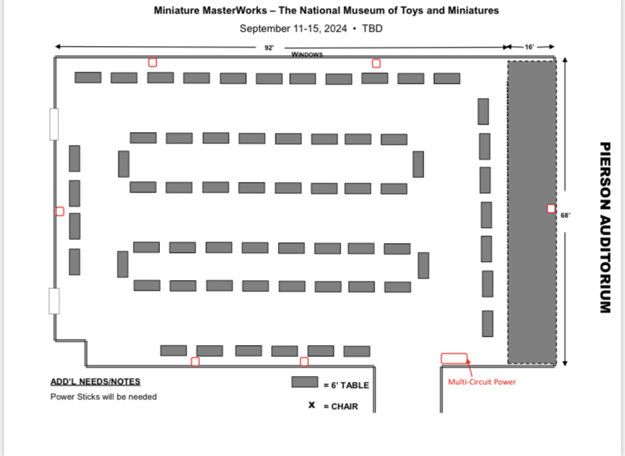
*Large rectangular gray band running the length of the right side is storage used by UMKC.

